Brazilian E-commerce store data Analysis for 2016-2018

Create the different metrics like Sales, customer acquisitions, total no. of orders for each Year across the different states they serve

Total sales for each year across the different states.

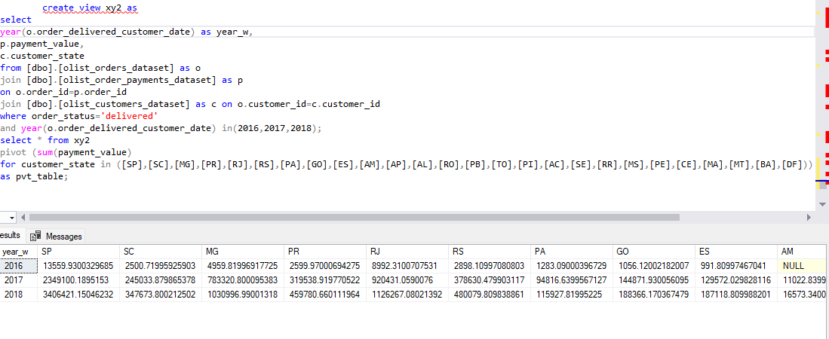

Customer acquisition for each year across different states

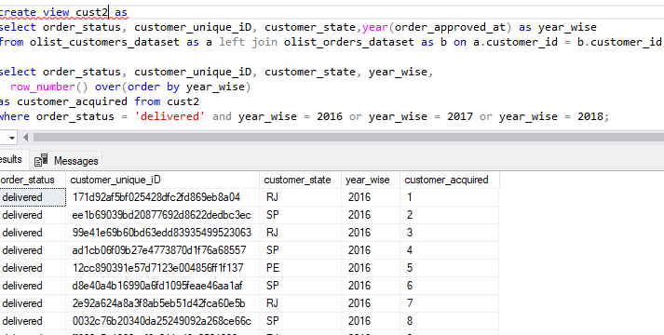

Total count of orders for each year in different states.

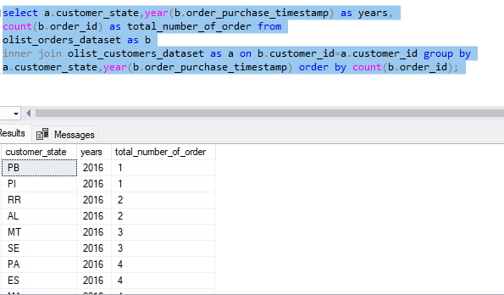

Decreasing trends of States in different years

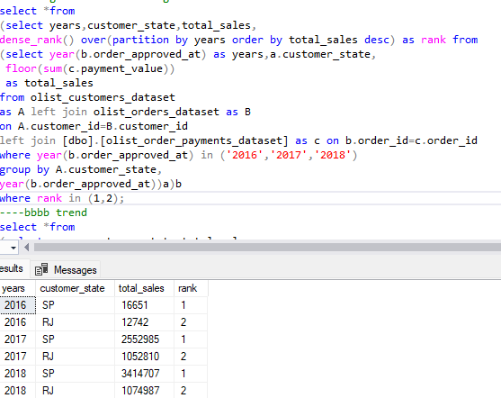

Increasing trends of States in different years

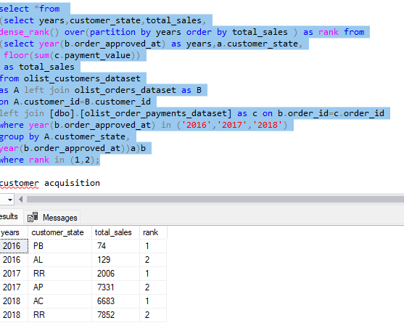

Percentage of orders delivered earlier than the expected date

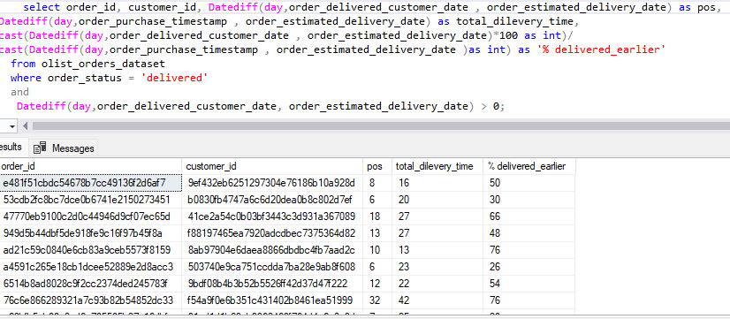

percentage of orders delivered later than the expected date

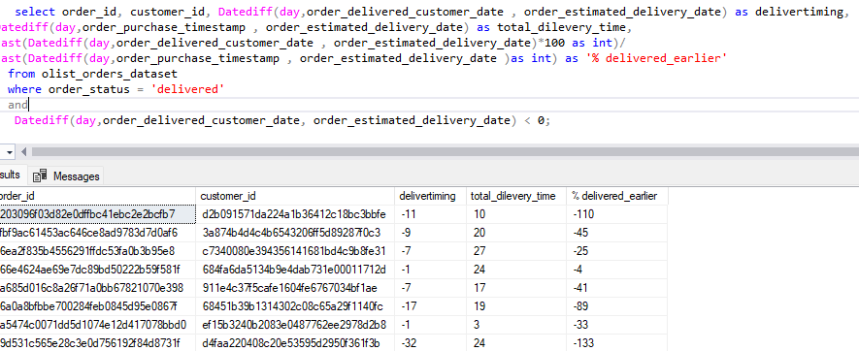

Category wise sales

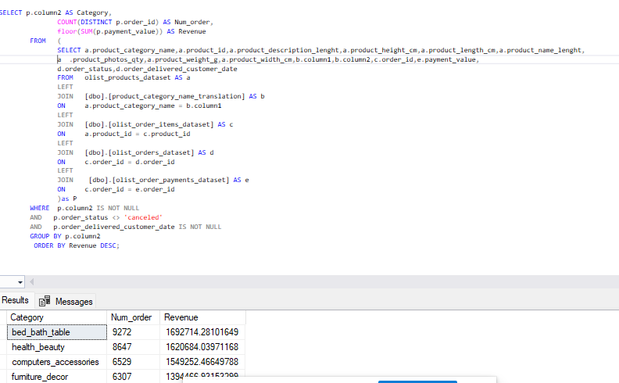

Seller wise performance of sales

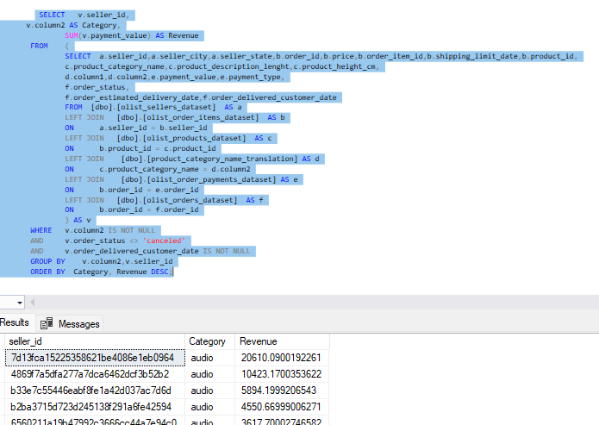

Product wise sales and order placed

